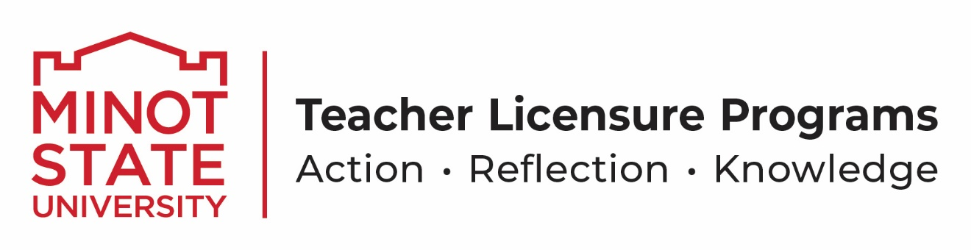

Dear Parent,

Minot State University is accepting students for our summer Early Literacy Camp. Students must have been enrolled in kindergarten, 1st or 2nd grade during the 2023 – 2024 school year in order to be eligible to be accepted. This program is intended for students experiencing difficulty in reading and provides an opportunity for your child to work in a small group (3-4 children per group) with someone to improve his or her skills and attitudes towards reading. We strongly believe that a child must enjoy reading so some of our time we plan fun activities where the students have to read the directions in order create a science project, recipe, art activity or game.

Here is some information about our camp:

- A $15.00 fee, due at the time of acceptance, is requested so we can purchase materials.

- Early Literacy Camp runs from June 10– July 18, 2024.

- Camp is broken down into 3 separate sessions. The Session your child is placed in will depends on their reading level at assessment (see next bullet point).
Sessions are:
Monday/Wednesday from 9-11
Monday/Wednesday from 1-3
Tuesday/Thursday from 1-3.

- We will assess your child’s reading level and phonemic awareness skills BEFORE the beginning of camp. We will be calling to set up appointment times for the assessments. We will assign camp sessions so that students with similar ability levels are grouped together.

- Please do not register or accept admittance into camp if your child will need to miss more than 3 sessions.

- This is a great opportunity for our college students to plan engaging lessons for your child as well as to continue to develop their reading skills.

Karen Foley
Karen.foley@minotstateu.edu
500 University Ave W Minot, ND 58707
701-858-3150

